**Mule Barn Brewing Company**

Warrensburg, MO

Business Plan

June, 2023

Prepared for Mule Barn Brewing Company in cooperation with:

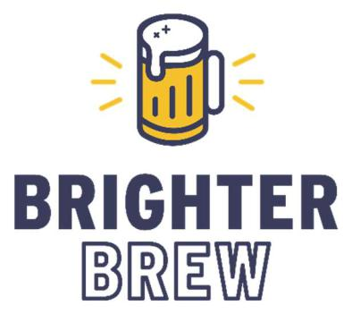

**Damn good results on tap.**

**Aaron Weaver, Founder & Chief Strategist**

**aaron@brighterbrew.com**

**Table of** **Contents**

**Executive Summary** 3

**Company Description** 4

**Market Research** 6

**Intellectual Property** 11

**Sales and Marketing** 12

**Personnel Plan** 13

**Financial Plan** 15

# **Executive Summary**

Mule Barn Brewing Company (MBBC) is a Missouri LLC and a new business aiming to offer locally brewed craft beer to beer lovers in Central Missouri and east exurban Kansas City. MBBC was founded by three entrepreneurs from Warrensburg: Andy Weldon, Christopher Barrier, and Dillon Jarrett. MBBC is seeking $300k in funding in order to begin operations.

MBBC has an opportunity to launch operations in an iconic building in historic downtown Warrensburg. Extensive market research and planning have been undertaken to prepare for their share offering and operations.

MBBC anticipates positive net income in its first year of operations, and expects investors to break even by or before the fifth year.

To inquire, please contact MBBC co-founder Andy Weldon at (660) 563-1590, or reach MBBC consultant Brighter Brew by email at [aaron@brighterbrew.com](mailto:aaron@brighterbrew.com).

# **Company Description**

Mule Barn Brewing Company will be located in Warrensburg, Missouri, near the University of Central Missouri and Whiteman AFB. It will be the first brewery in Johnson County, and will serve as a local watering hole for the nearby community with brewed-on-site beer, craft cocktails, and simple food offerings.

## Retail and Manufacturing Location

The planned location is a historic building in the downtown central business district, within walking distance of the university and nearby housing, known as the Mule Barn. The building’s history goes back to World War I, when it was used as a sales barn for draft mules. It existed as a hardware store for several decades after the war, and has been vacant since the early 2000s. It was added to the National Record of Historic Places in 2010 and is well-known throughout Central Missouri. The owner is willing to contribute to the renovation of the building to make it suitable for retail occupancy, as a result of favorable tax conditions granted for renovating the historic building. The property would be rented from the current owner, with an option to purchase it in the future.

## Ambience

The location in a historic building will have a significant impact on the ambience of the interior tap room space. Branding colors will be used as accents, while effort will be made to highlight elements of the historic construction, as well as to draw in natural light.

## Service Standards

Service style will be relaxed and friendly, and guests will be invited to approach the bar to place food and drink orders, rather than offering traditional table service. Food will be retrieved by guests from a pickup window when ready, limiting the need for additional food service employees.

## Legal structure

Mule Barn Brewing Co. is a Missouri Limited Liability Company, privately funded by Andy Weldon. Christopher Barrier and Dillon Jarrett will also hold minority stakes and will assist in strategic operation and daily operation on an as-needed basis.

## Experience

Weldon, Barrier, and Jarrett have been homebrewing for several years, and have won nine medals at competition, including three gold medals and two scale-up contests. In addition, Andy has worked professionally in the brewing business since 2021 as a brewer at East Forty Brewing in nearby Blue Springs, Missouri.

## Start-up summary

Approximately $300k will be needed to cover start-up costs, based on asset purchase of $242k and $60k in start-up expenses.

Brewing equipment will be leased to own, limiting the capital required for manufacturing. In addition, a large proportion of the building renovation will be undertaken by the building owner, mostly including preparation of the site to serve as a foodservice and drinking establishment, such as installation of a bar, walk-in cooler, and limited commercial kitchen, as well as preparation of indoor and outdoor dining spaces. Renovation required to be funded by MBBC will therefore be limited to the work required to prepare the brewing space to receive equipment and the renovation of the front of house to incorporate MBBC branding.

Including the cost for branding, $60k has been planned for all interior and exterior renovation to be undertaken by MBBC, and an additional $45k has been planned for any additional furnishing and kitchen equipment required.

A total of $75k has been planned for all necessary brewing equipment and cooperage not included in the leased brewing, fermenting, and serving equipment.

$35k is planned for IT expenses to include point-of-sale, ERP, and back-office software and hardware, and a 10% contingency has been applied to the full list of capital expenditures as a best practice.

Start-up expenses of $58k will cover training and marketing in advance of open, and two months of operating expenses.





# **Market Research**

## Industry trends

The craft beer industry has been consistently growing in the US in terms of number of businesses, volume produced, dollar sales, and share of the US beer market since at least the 1970s, according to the Brewers Association. Despite a dip during the pandemic-induced upheaval of 2020, the industry has seen a bounce back in 2021 and 2022. For more information on these national trends, see the Brewers Associations [national trends page](https://www.brewersassociation.org/statistics-and-data/national-beer-stats/) which is updated annually, and see the [2021 Annual Report of The New Brewer](https://mydigitalpublication.com/publication/frame.php?i=747438&p=&pn=44&ver=html5), both publicly available.

According to the Brewers Association’s annually compiled state-by-state data, while the 157 breweries in Missouri at the end of 2021 ranks 18th among US states, placing it in the 2nd quartile, Missouri is in the 3rd quartile in terms of breweries per adult over 21 (ranking 28th), volume produced per adult (25th), and annual economic impact of the industry (32nd), meaning that the industry overall is under-indexed in the state per LDA adult.

Credit: Brewers Association

## Original Research

Consulting firm Brighter Brew, LLC executed a detailed market research project to understand the brewery business landscape at a more local level. A complete market research report is available for consideration, and this section summarizes the key findings.

There are no operating breweries in Johnson County. The nearest concentration of breweries is in the Kansas City metro Area, 40-50 miles away. Click on the map below for an interactive map of the breweries in the state of Missouri.

](https://aarweav.github.io/bullseye.html)

72 of the 115 counties and municipalities in Missouri do not have operating breweries. Of those 72, Johnson County has one of the highest populations, one of the highest LDA populations, and one of the largest economies. With one brewery in operation, it will still have one of the lowest per capita counts of breweries in the state.

For further explanation of the demographic and economic research, please see the detailed market research report, which utilizes data from multiple sources along with cutting edge analytics to paint a comprehensive picture of market opportunity. The report includes multiple additional interactive maps, charts, and projections.

## Competition

The most craft beer focused bar in the area is Fitter’s Pub downtown, which has several craft beers on tap, and a cooler with large selection of national craft beer for take-out.

Hero’s Restaurant downtown has a handful of mostly domestic beers on tap, and has expressed interest in having MBBC’s brews as well.

Players Restaurant is just off Highway 50 in town, and has a bar with 10 beers on tap, mostly domestic.

The nearest brewery or brewpub currently in operation is in Lee’s Summit approximately 30 miles away in metro Kansas City.

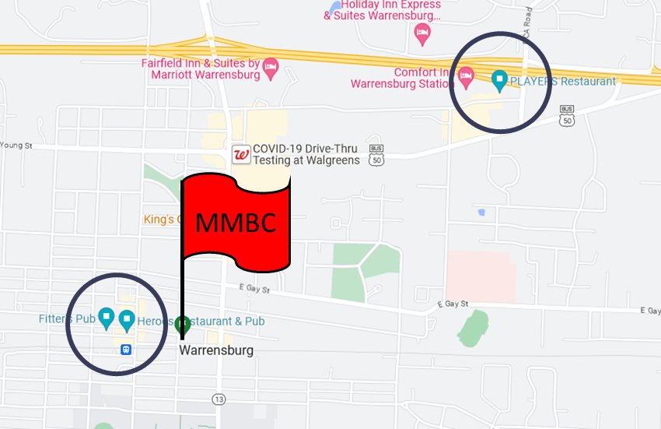

## Competitive Advantages

Mule Barn Brewing will be the only brewery or brewpub in the city of Warrensburg, the county seat and largest city in Johnson County, Missouri. Of the four bordering counties, three also do not have breweries in operation. As the only brewery in the area, a number of local businesses have expressed interest in partnering with MBBC which would make them an integral part of the local community.

## Regulations

The city of Warrensburg requires food to be available in order to serve liquor by the drink. The founders intend to have craft cocktails on draft, so they have planned a small commercial kitchen in order to satisfy this requirement.

Both the city of Warrensburg and the state of Missouri require a variety of annual permits and licenses in order to sell beer and liquor on-premise to consumers, and to allow package sales to go. These have been accounted for in the pro forma. The state of Missouri levies excise taxes in the amount of $1.86/bbl.

The TTB requires registration in order to track and pay federal excise taxes. This registration is free. Current federal excise taxes for breweries producing under 2 million bbls amounts to $3.50/bbl.

**Business Model**

## Primary Business

MBBC will operate under the brewpub business model, with beer brewed locally on-site, as well as simple food offerings, crafted batch cocktails, branded merchandise, and limited retail sales of their own beer to-go. In total, their retail sales are expected to constitute greater than 90% of their total revenue.

## Additional Revenue Sources

## In addition to their primary business, MBBC will engage in limited, local self-distribution of their own products to on-premise bars in the area with craft beer-focused bar menus. While this is expected to drive just a few percent of total revenue, it will also drive brand awareness and traffic to their own retail location.

## They will also have an additional space upstairs from their primary retail space that will be utilized for private parties and events. They will also rent out a portion of their retail space during off-peak and non-opening hours for meetings and events. While the revenue derived directly from event fees is expected to be incremental, it will also drive additional retail traffic and volume.

# **Intellectual Property**

Mule Barn Brewing Company has registered their name with the US Patent and Trade Office. Accounts have been parked on Facebook, Instagram, Twitter, LinkedIn and YouTube, and the domain mulebarnbrewing.com has been purchased.

The founding team has also developed dozens of successful recipes, including the aforementioned nine award-winning recipes.

# **Sales and Marketing**

To drive awareness with local consumers, MBBC will primarily utilize social media and local partnerships. Local businesses interested in partnering include new local barbecue outlet Mulekickers BBQ, Green Truck Bakery, local butcher Alewell’s Meats. In addition, MBBC has made a successful effort to turn all potentially competitive drinking establishments into possible sales and marketing channels through self-distribution.

Social media presence will be managed by the general manager, until such time and scale that the role grows to the point that this task along with marketing and events can be delegated to an FTE.

The City of Warrensburg also hosts a variety of local festivals and events Downtown where MMBC has the opportunity to be the exclusive local brewery offering their product. This will drive local awareness, trial, and incremental revenue.

The primary sales channel will be on-premise through their own tap room and brewery in Warrensburg. Limited to-go sales are legal in Missouri, so a small amount of beer is planned to be packaged exclusively to be sold to-go at retail from their own property. Limited self-distribution is also legal in the state of Missouri, so as awareness grows, there will be potential to self-distribute a limited quantity of draft beer to local bars and restaurants. No sales through the wholesale channel are planned in the in the first years of open.

# **Personnel Plan**

Co-founder Andy Weldon will be the brewmaster and handle day-to-day brewing operations. Andy has 2+ years of experience in professional brewing in his 15+ year professional career.

Managing day-to-day business operations in the restaurant and taproom will require hiring a General Manager. There is a candidate identified with 15 years of public-facing professional experience.

Leading the front-of-house will be a bar manager, who tends bar full time and also manages front-of-house scheduling, hiring, ordering, inventory, and other administrative tasks. Similarly, the kitchen will be led by the head cook, who will manage the kitchen administratively while working full-time in the kitchen. Additional bar and kitchen staff will be part time to start.

Future plans as the business scales include hiring an assistant FOH manager, a marketing and events manager, and an assistant brewer. All of these would be part time to start and would be timed according to need.

# **Key Partners**

Business Consulting – Brighter Brew

Legal – Craft Beer Attourney

POS – Arryved

ERP – Beer30

Accounting – Laura Mikeworth, CPA

Food service – Sysco, Springfield Grocer

Creative – 818 Design

Marketing and consumer engagement – Untapp’d

Beer ingredients – BSG, CMG, BSI, ProBrewer Supply

Hops – Yakima Chief, Crosby, Hollingberry

Municipal services – City of Warrensburg, Spire, Missouri America Water, Evergy

# **Financial Plan**

A detailed pro forma financial statement has been developed by consulting partner Brighter Brew. The plan assumes a 100-seat retail space, indoor and outdoor, and includes detailed assumptions of the variability of traffic by day of the week and month of the year, splits of the amount of beer, cocktails, and food purchased by each guest, and frequency of a guest making a to-go purchase. The plan sums to a very conservative check average of under $19/guest.



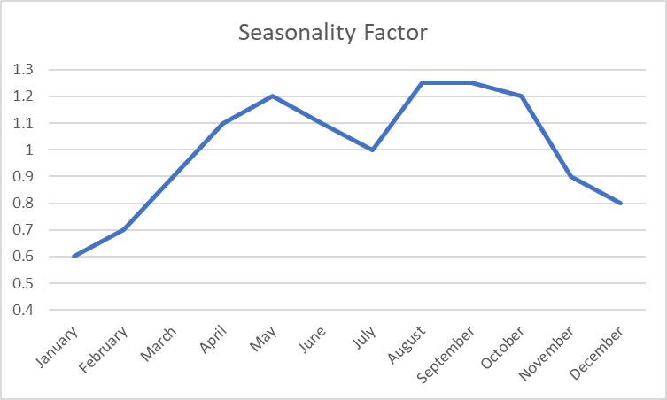

## Revenue assumptions

Based on the traffic assumptions above, detailed assumptions were then made about beer product mix, serving sizes, and draft prices in order to build beer revenue into the pro forma P&L. Beer revenue (including to-go and self-distribution) constitutes approximately two-thirds of total revenue.

Food and liquor revenue have been estimated by high-level conservative assumptions about food check average, and the percentage of guests expected to order cocktails vs. beer. Food and liquor revenue constitute a little over 20% and 10% of planned revenue, respectively.

Wholesale beer sales were estimated at 10% of retail beer sales by volume, and constitute about 2% of planned revenue.

Events are planned to constitute around 6% of revenue, and merchandise are planned to be around 1% of revenue.

## COGS assumptions

Beer material COGS were estimated through detailed product-by-product cost estimates based on Brighter Brew’s experience, and detailed packaging cost assumptions. Retail beer COGS added up to about 5.7% of retail beer revenue, which is in line with brewpub model benchmarks of 4-8%. Given the lower revenue per unit and associated packaging prices, wholesale beer and to-go beer COGS are estimated at 13% and 29% respectively. Food, liquor, and merchandise were estimated at the high level at a conservative 30%, 25%, and 75% respectively. Production and taproom operation wages were included in COGS as well, leading to a total COGS in the low- to mid-40% range.

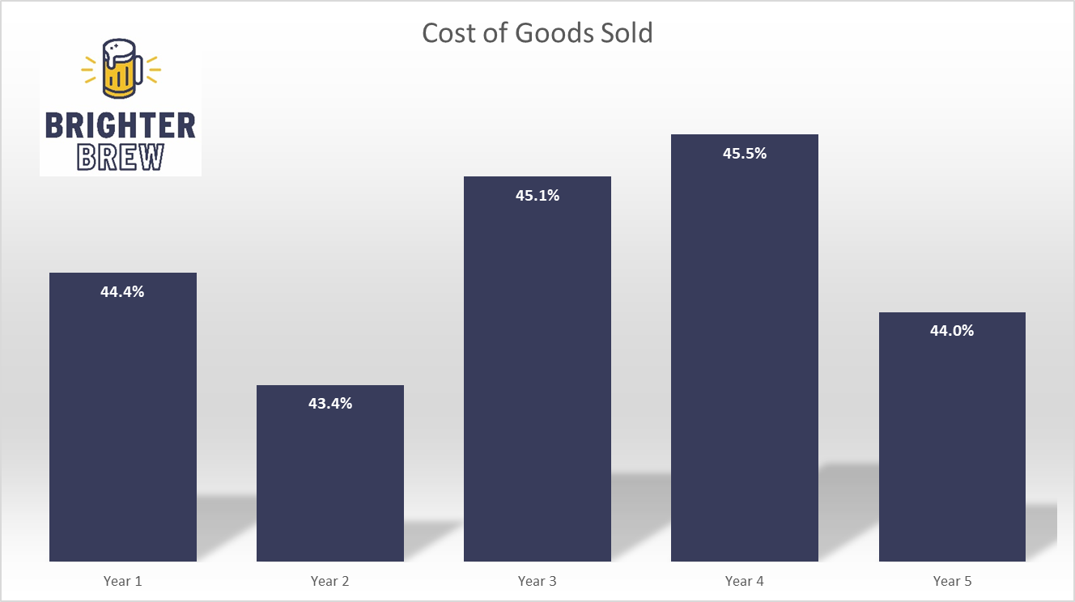

## SG&A Assumptions

SG&A costs were assumed in detail and are estimated at 40-45% of revenue. The largest categories of cost driving SG&A are occupancy and wages & salaries.

## 

## Financial Summary



By year 5, MBBC is expected to achieve 15% EBITDA margin, which is a good industry benchmark for breweries of this approximate size and on-premise focus.

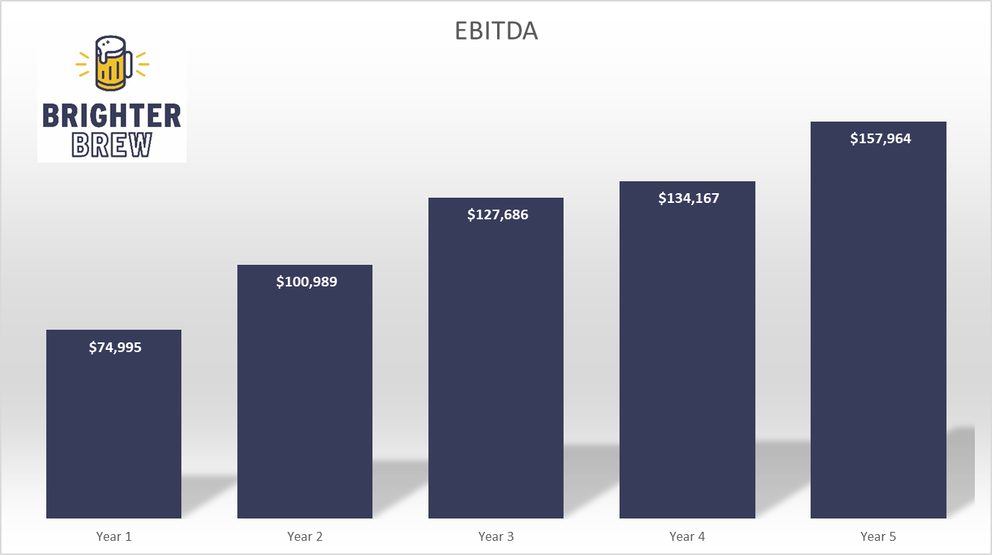

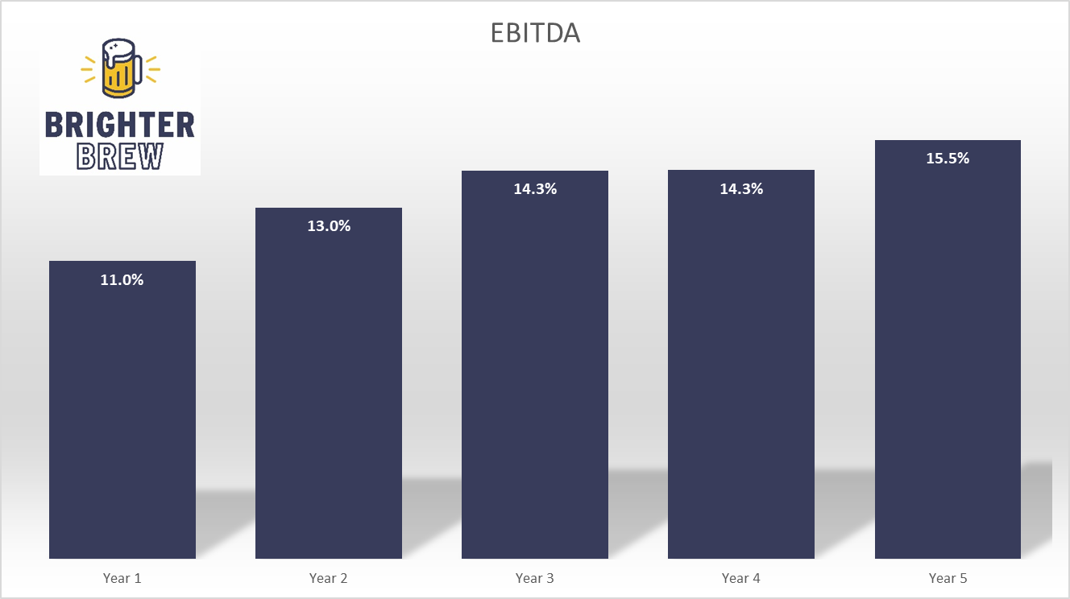

MBBC anticipates a positive net income from its first year of operations.

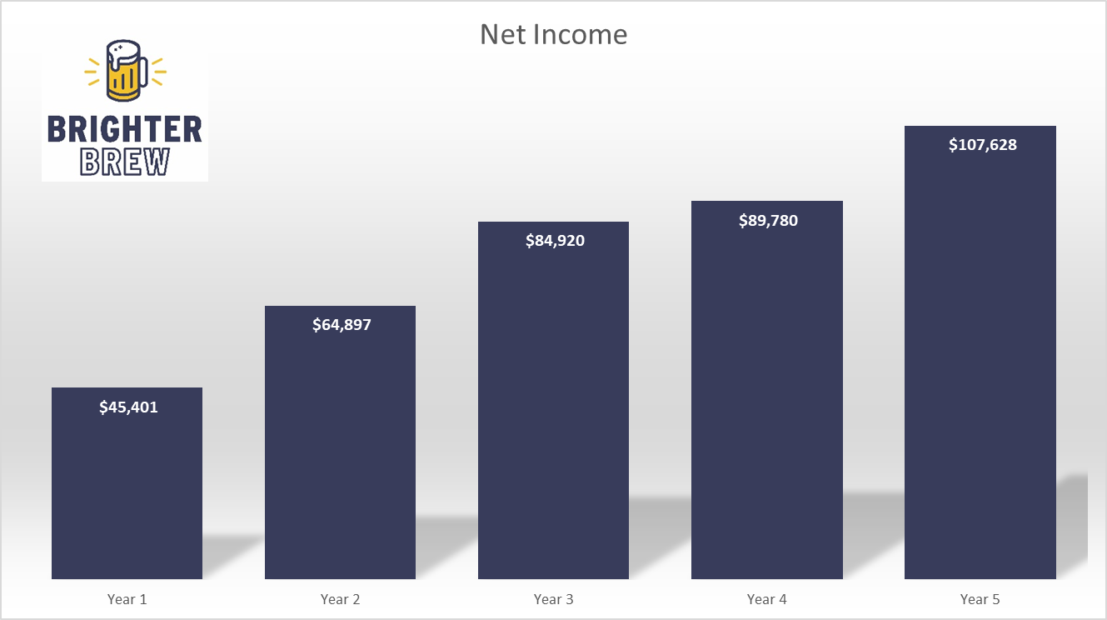

MBBC projects to have broken even for investors by the fifth year, while continuing to reinvest a portion of profits in growth each year.

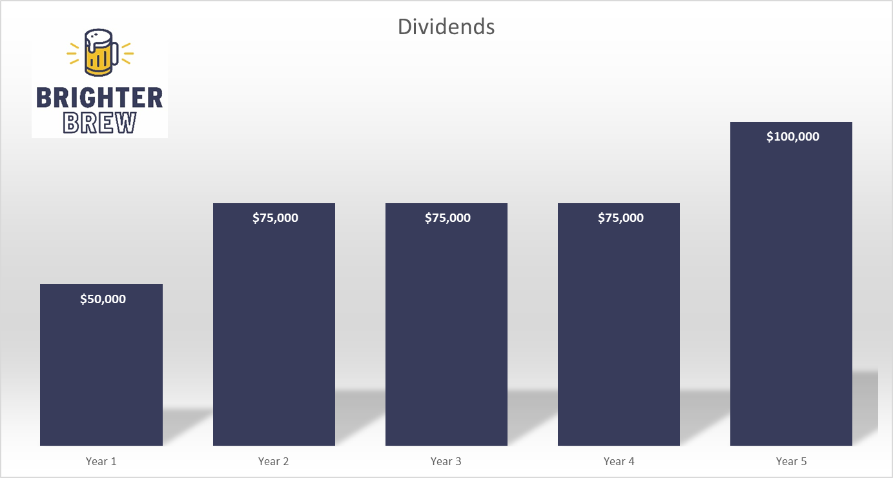

## Funding

MBBC is seeking $300k in funding, via a share offering of 12 shares at $25k each, which in total will constitute a 50% ownership in the company. Equity shareholders will be paid back in entirety before any dividends are distributed to non-equity shareholders.